Main_Back

background of window elements like txt boxes, a thin border around all controls, etc.

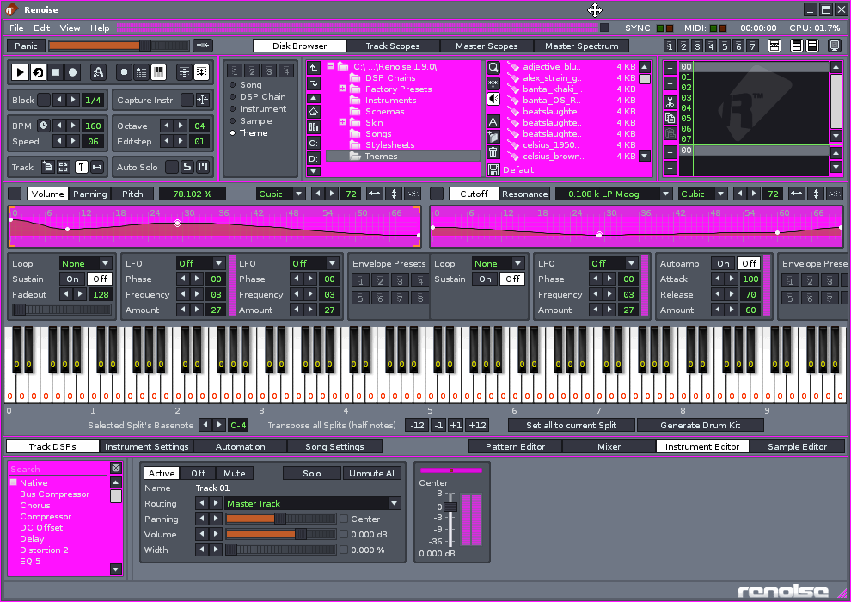

Main_Font

Used for +/- in tree view, text inside controls & edit boxes

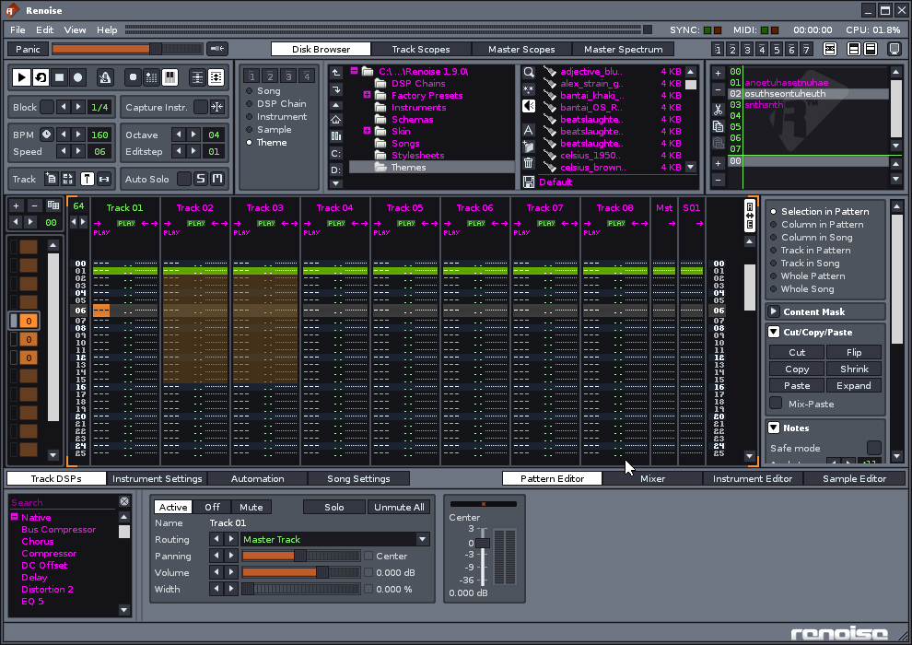

Body_Back

For controls where a solid body is drawn, this is used. It is shaded a lot.

This is for menus too.

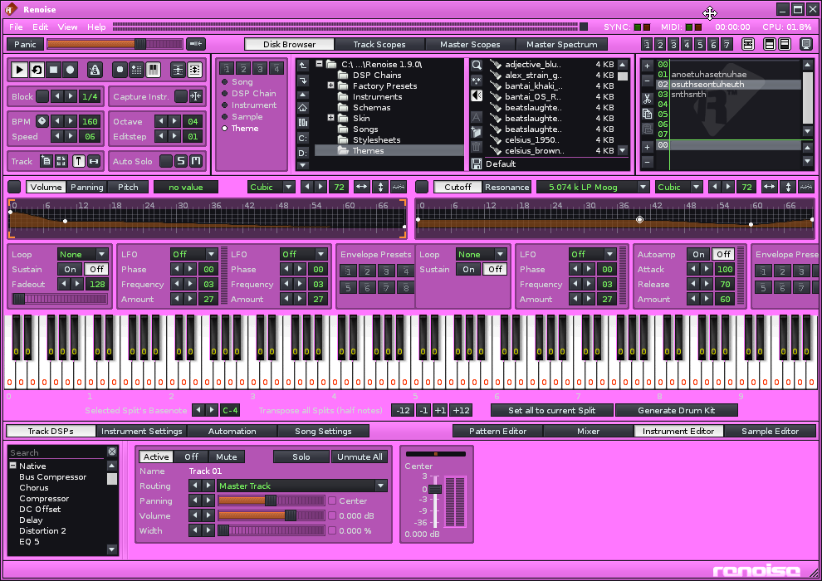

Body_Font

Used for NORMAL text on solid body background.

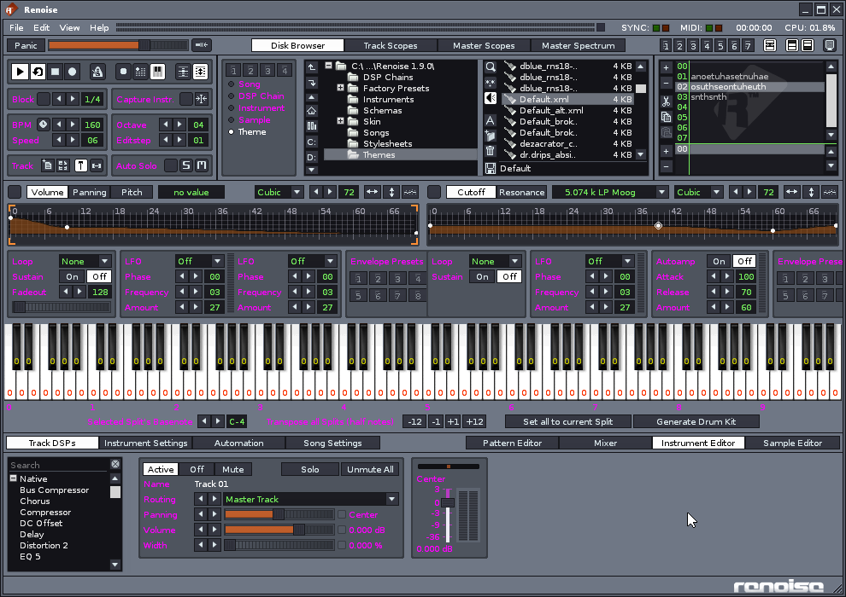

Strong_Body_Font

Used for selected & emphasized text & menu text on a filled body bg.

And for the title bar & logo watermark

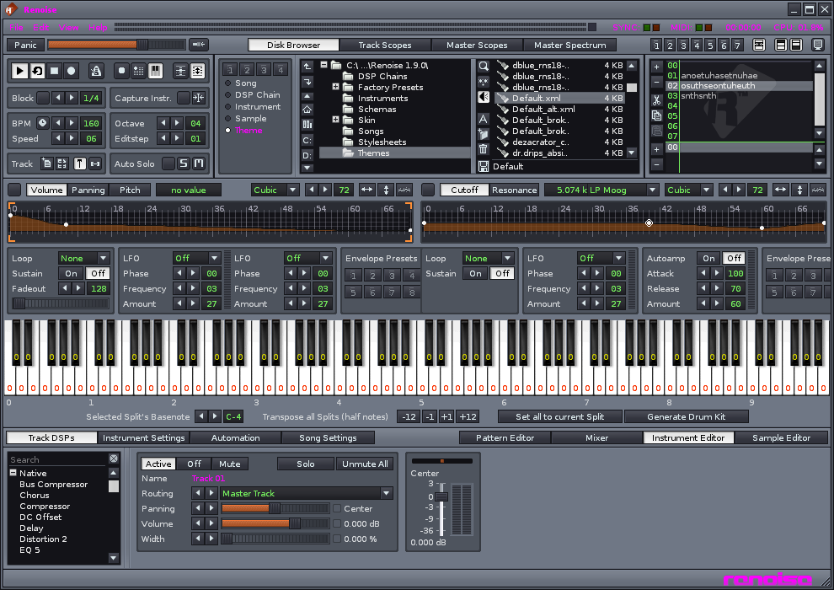

Panel_Back

used for meters’ background.

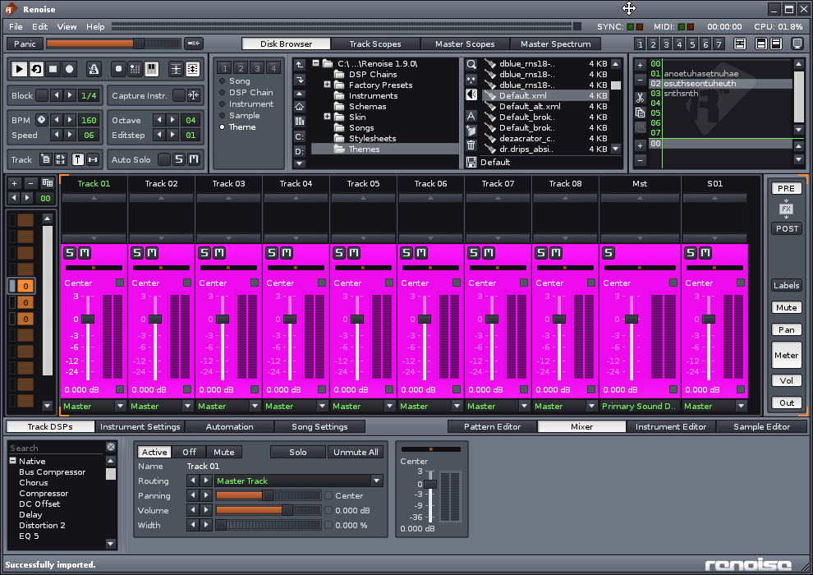

Panel_Font

Used for meters foreground – text / slider background.

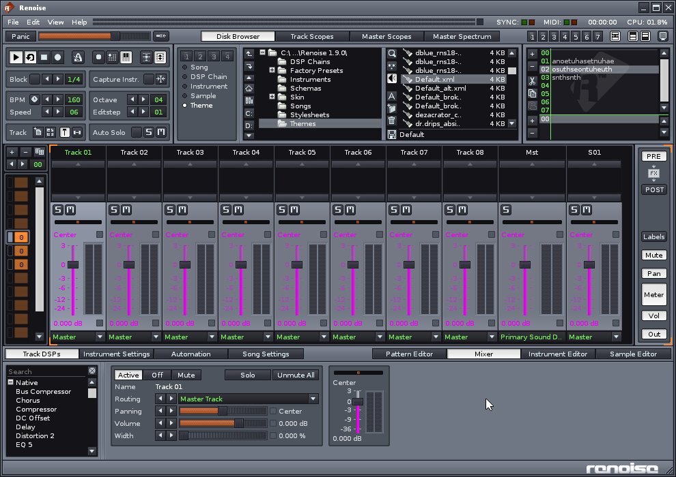

Button_Back & Button_font

Background color of buttons, tabs that are not selected.

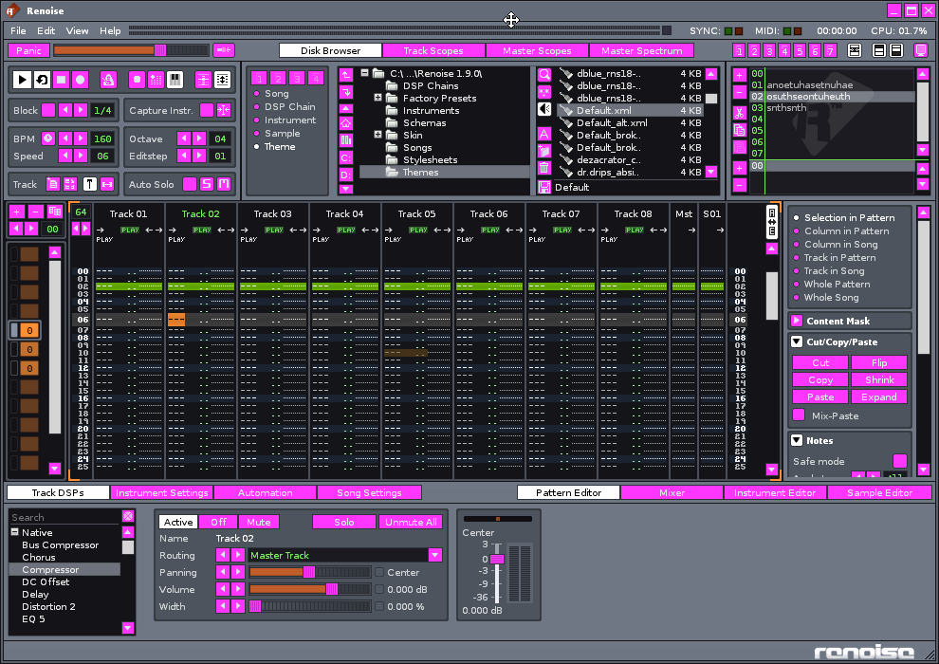

Selected_button_back / font

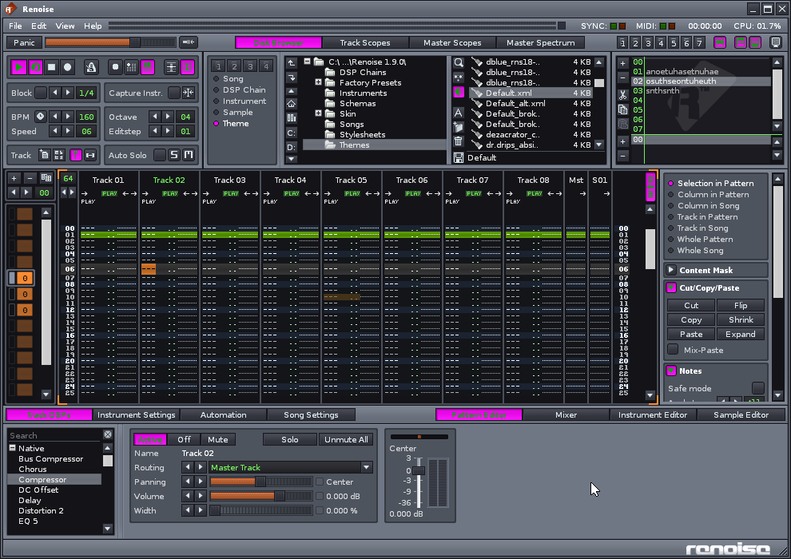

Selection_back

Used for selected menu items, cursors, focus rectangles

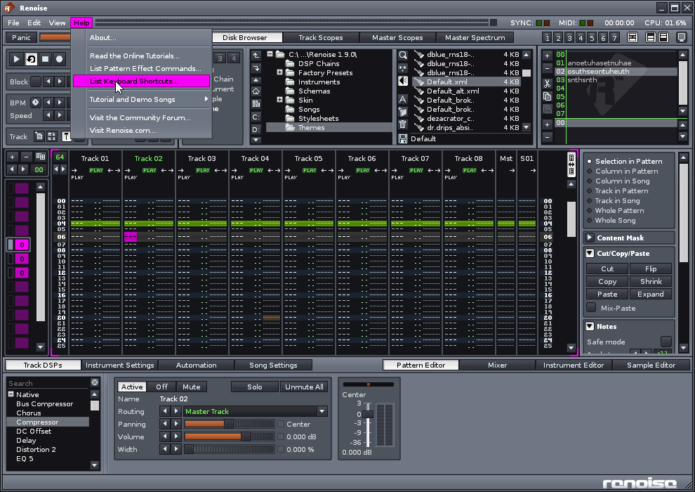

Selection_font

By the way, when a window is inactive, it doesn’t show any selected stuff, except in the case of Renoise it does show the pattern list but that’s sort of a 1-off, not really a selection. Notice mouseovers use a blending effect – ONLY for these types of buttons though.

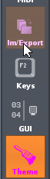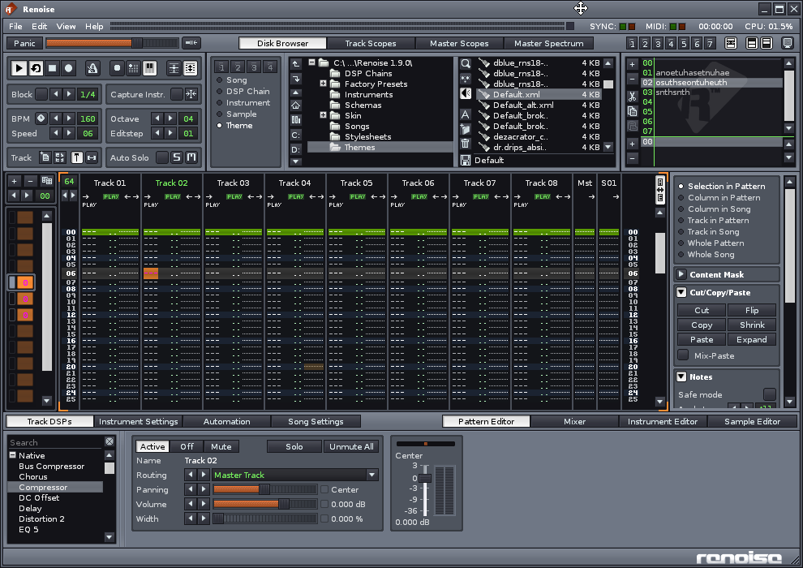

StandBy_Selection_Back / StandBy_Selection_Font

I think the idea here is if the window does NOT have focus, this is what is used for selection stuff. But in fact many selection items are always set to standby, even if the window is activated.

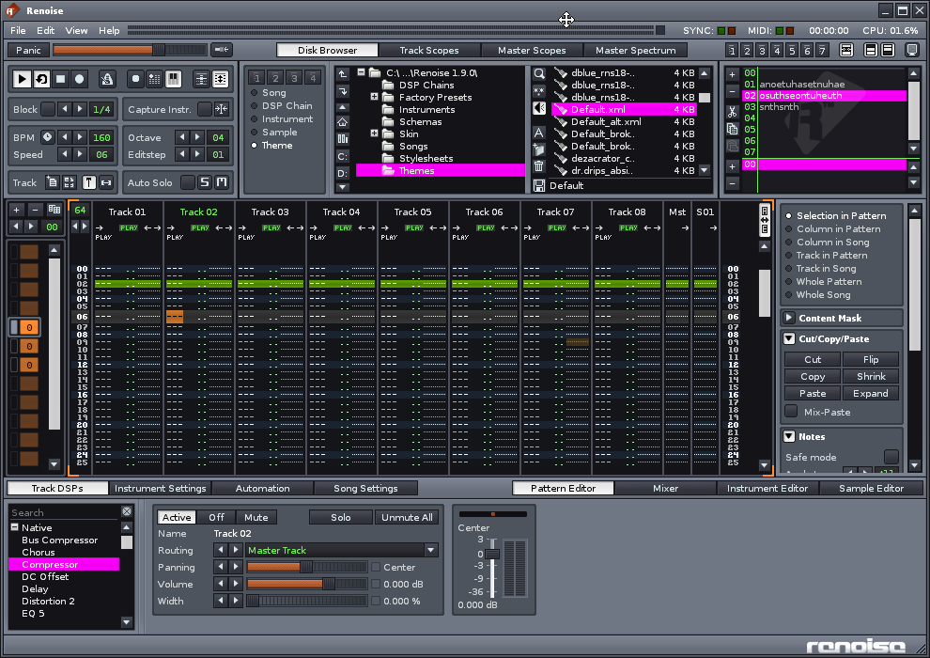

ToolTip_Back



ValueBox_Back / Font

For value controls like with the up/down controls, comboboxes (including their dropdowns), and … some lists, and even some borders around the mixer area.

Interesting – the instrument area does not get this value though.

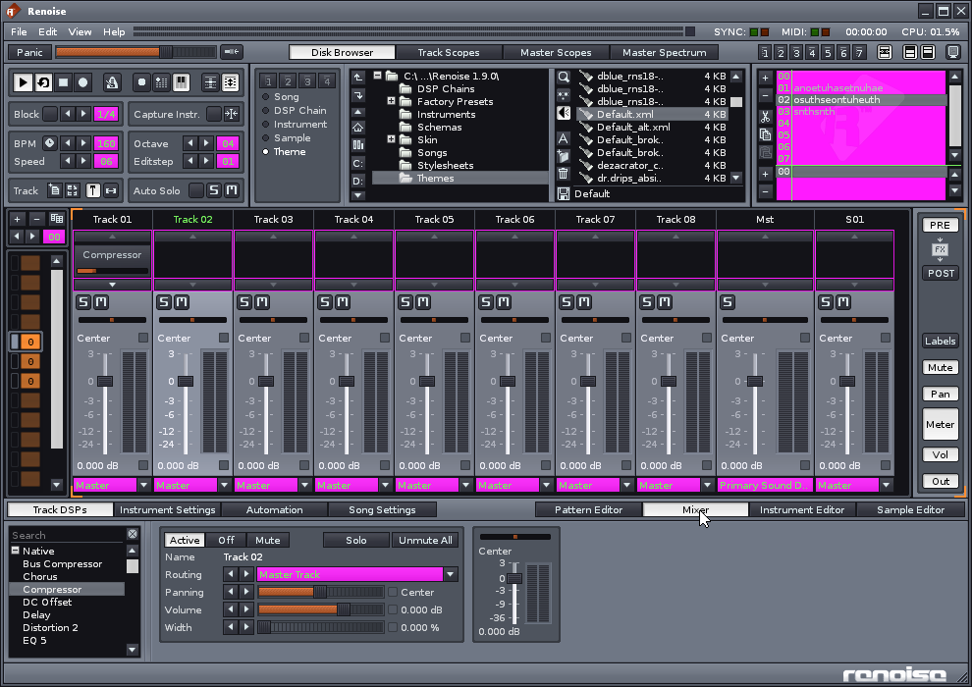

SliderBar_Back

Sliders. Notice the shading when the bar itself has handles.

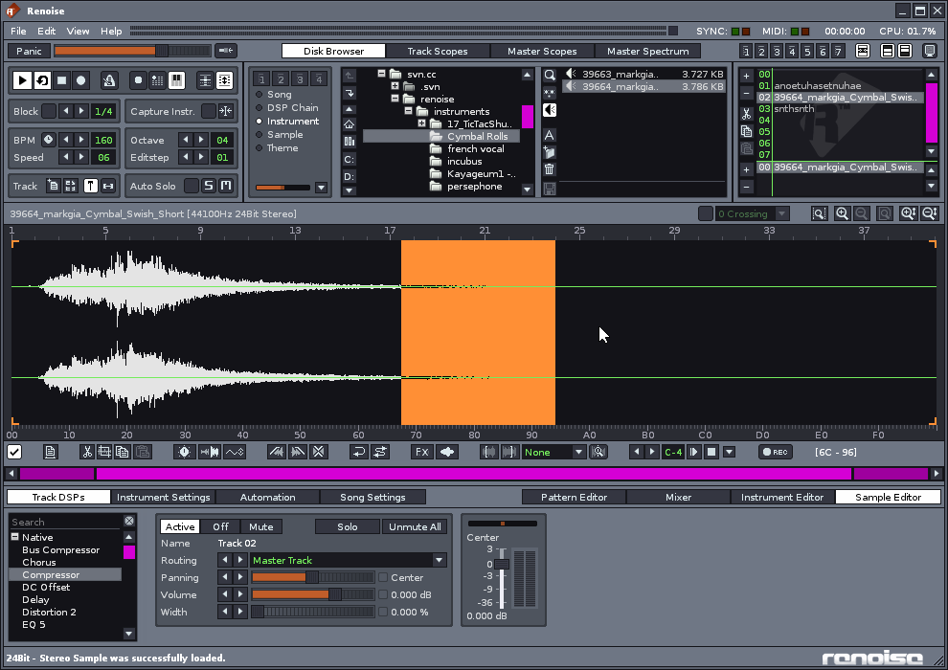

BodyTexture.bmp

Color information is discarded. Tiled. Used for

* Inactive window captions
* Body, but not on a “frame”

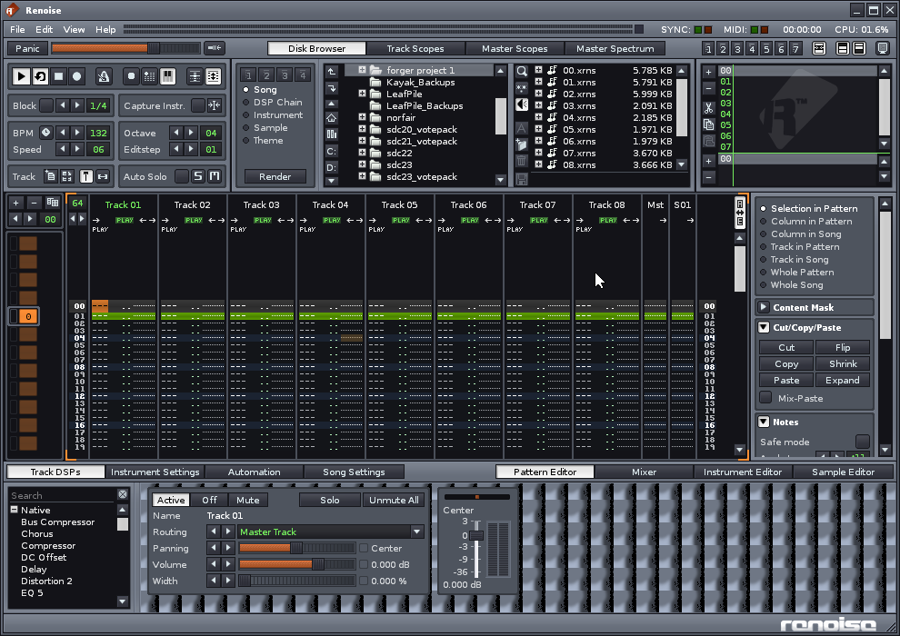

Buttonblending.bmp & ControlBarBlending.bmp

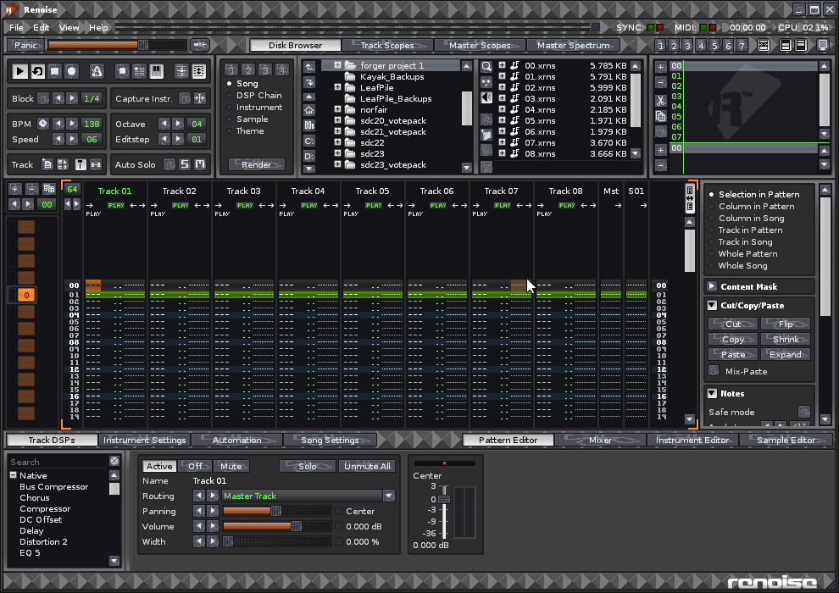

HSliderBarBlending



InnerBodyTexture

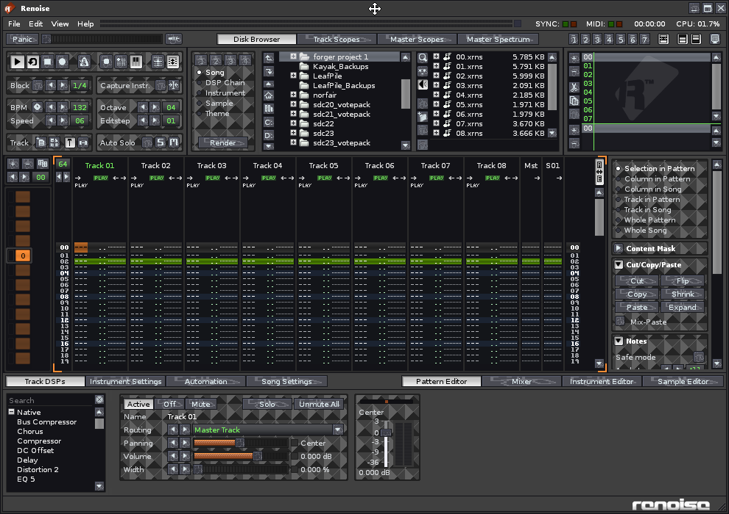

PressedButtonBlending

